SignUp Form
Upload the solution, WITH images!
Create a Web page (HTML5 + CSS3) that looks like the screenshot below:
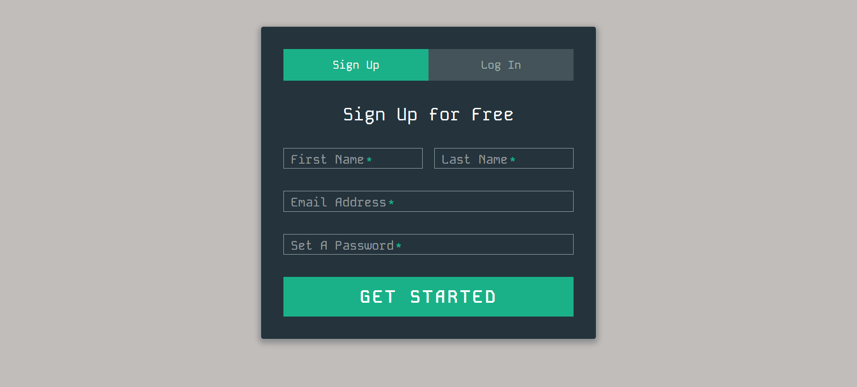
Use hover effect for "Log In" button, like the picture below:
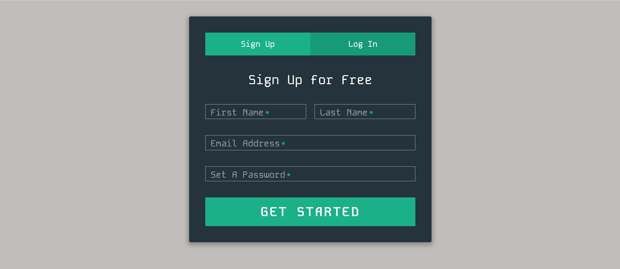

Output
The output should be valid HTML5 + CSS3 + images that implement the above web page.

Constraints
- Use font Kode Mono: https://fonts.googleapis.com/css2?family=Kode+Mono:wght@400..700&display=swap
- The site should open correctly in the latest version of Chrome

